DTL Assignment 7 : Bash Scripting

1. Making new file and entering text into it
2. Making the file executable
3. Listing all the files in directory
4. Executing the file

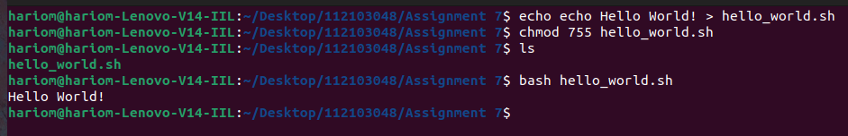

1. Adding multiple lines to a file
2. Changing permission of the file created
3. Listing all the files in the directory
4. Executing the file

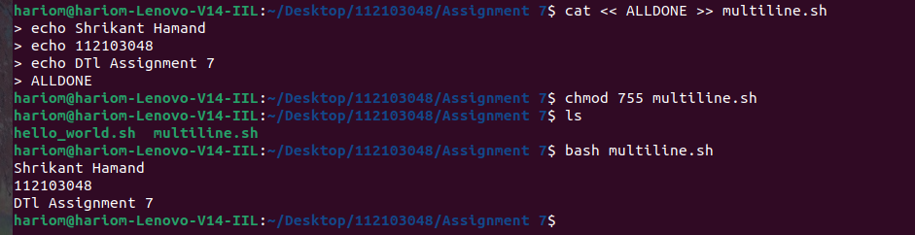

1. Opening Downloads directory
2. Creating a new file with current timestamp
3. Opening the file
4. Changing permissions
5. Listing the files in the directory
6. Executing the file

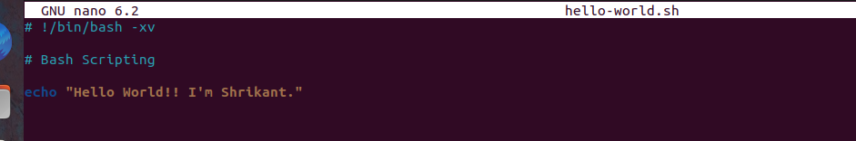


Special Parameters:

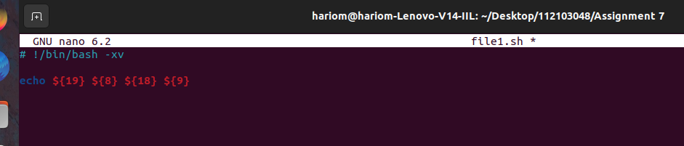

Exploring all special parameters:

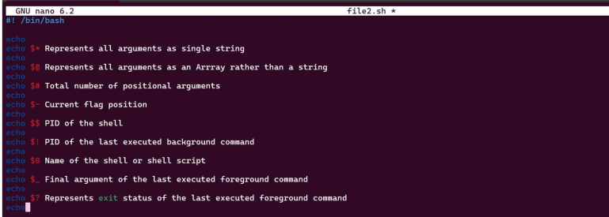
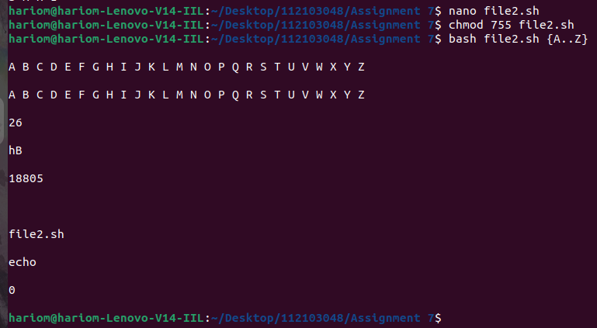

Bracket Expansion:

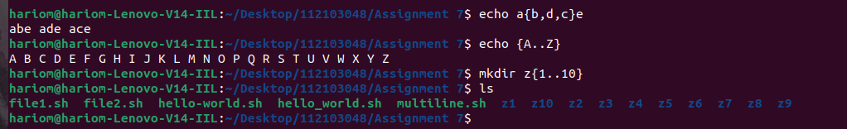

Using variables:

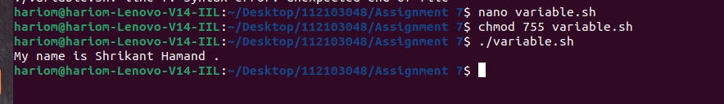
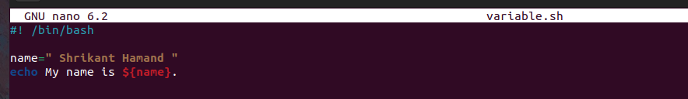

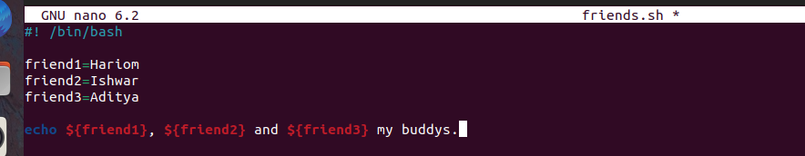
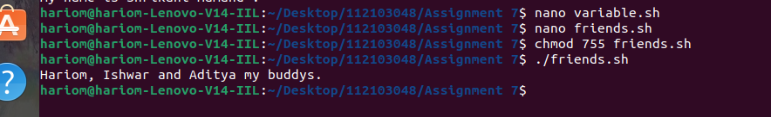

Arithmetic Expansion:
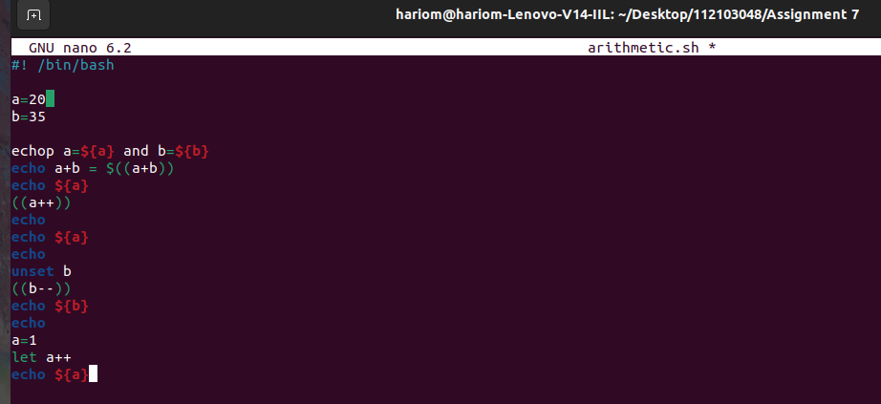

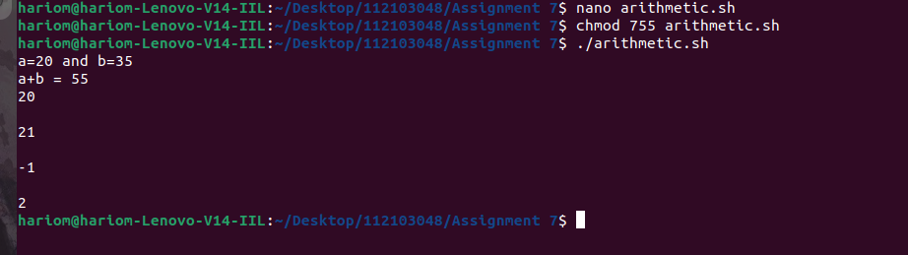
Command Substitution:

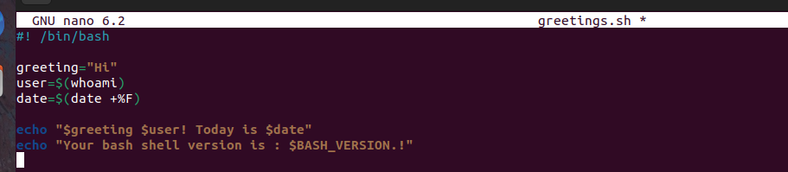

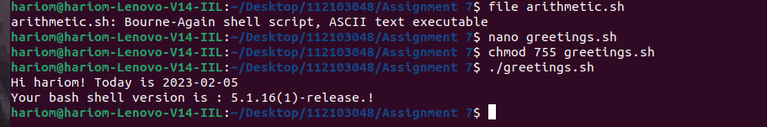
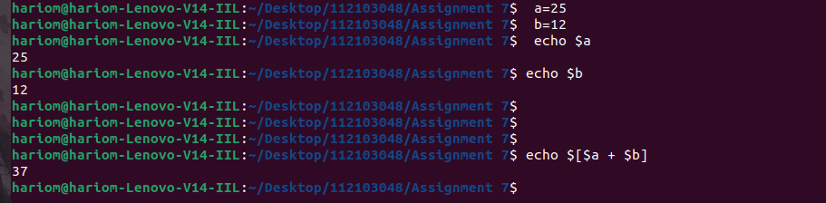

Creating Backup:

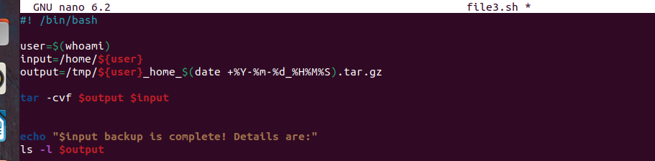
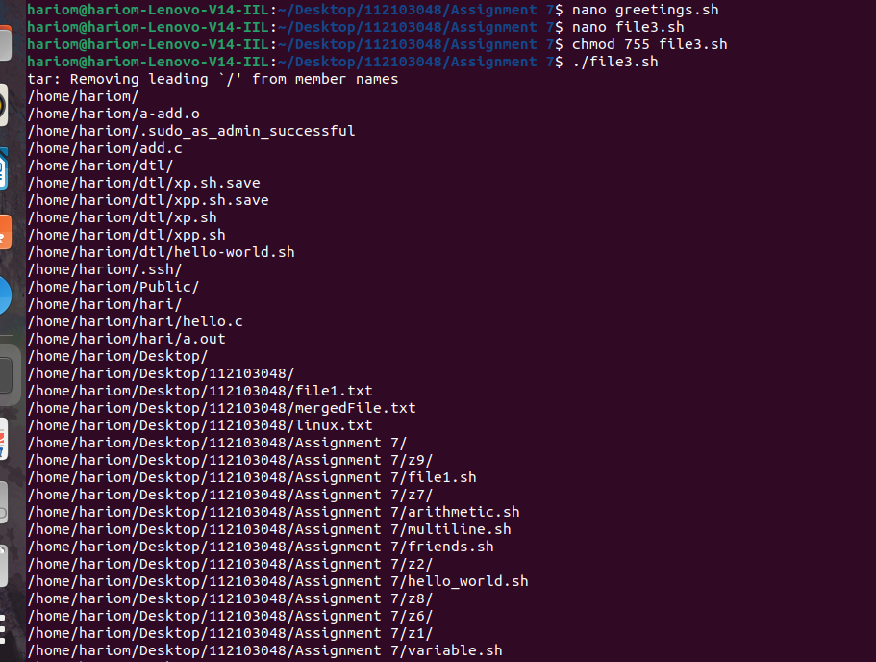

Environment:

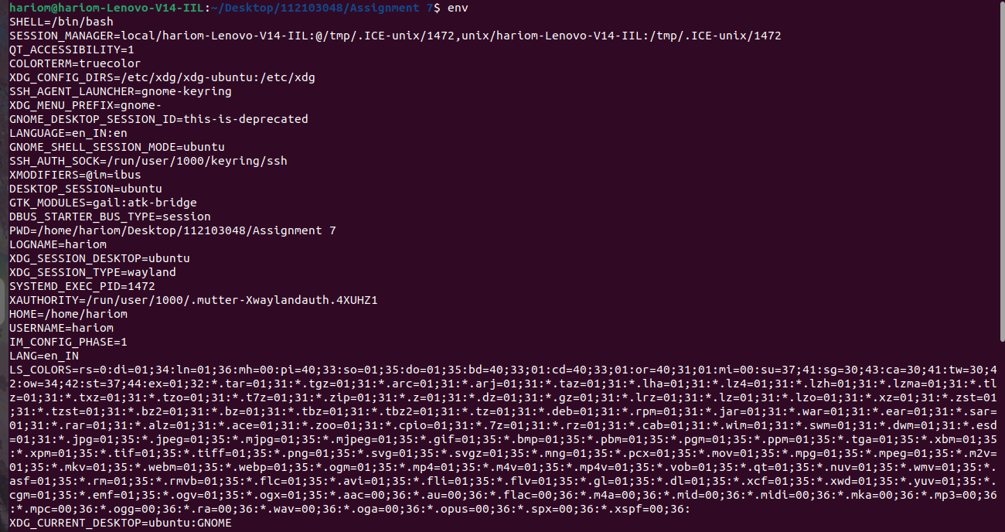
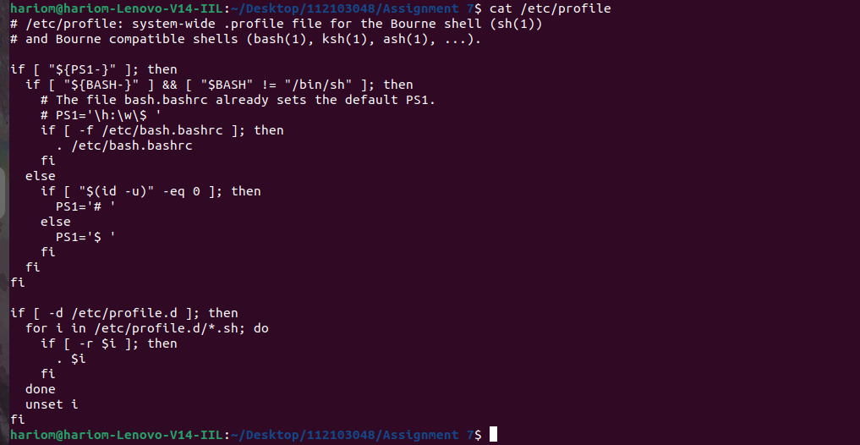

Input and Output Redirection:
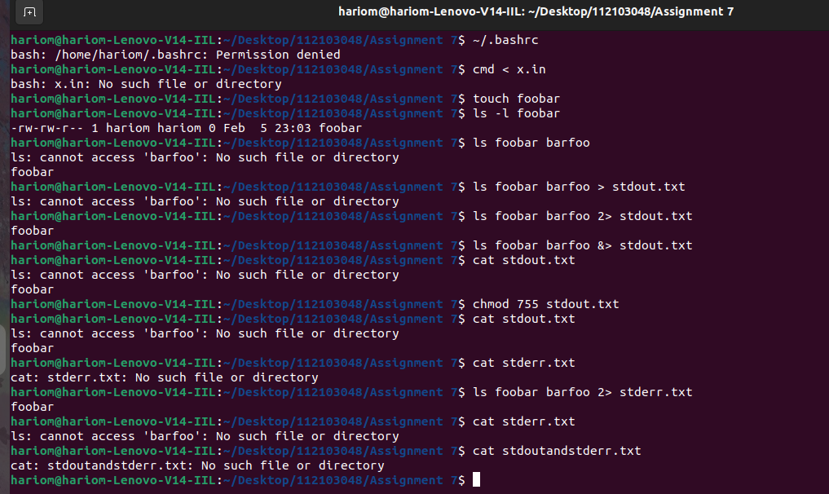

Functions:

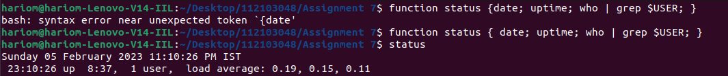

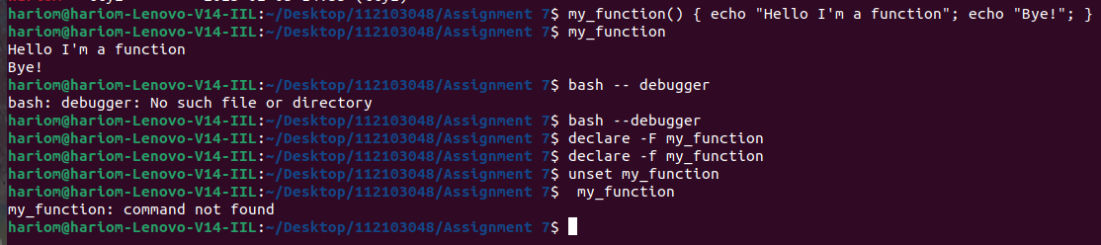

Conditional statements:

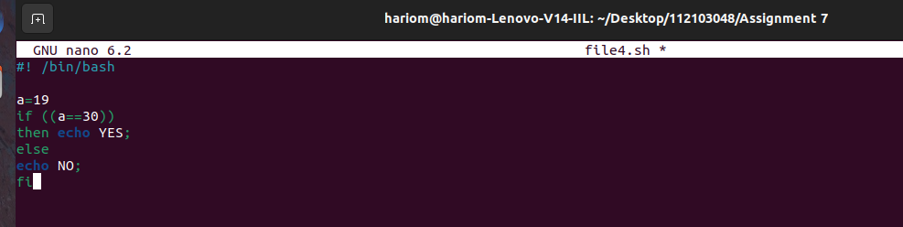


Arithmetic Expression:

